**Climate change: How do we know?**

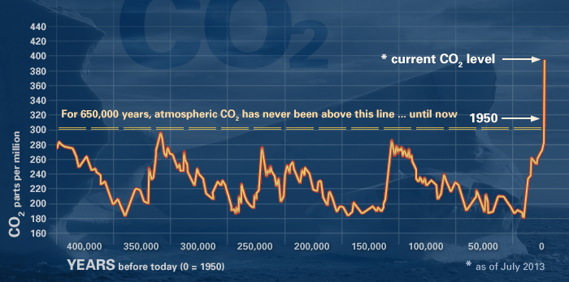

This graph, based on the comparison of atmospheric samples contained in ice cores and more recent direct measurements, provides evidence that atmospheric CO2 has increased since the Industrial Revolution. (Source: [NOAA](http://www.ncdc.noaa.gov/paleo/icecore/))

The Earth's climate has changed throughout history. Just in the last 650,000 years there have been seven cycles of glacial advance and retreat, with the abrupt end of the last ice age about 7,000 years ago marking the beginning of the modern climate era — and of human civilization. Most of these climate changes are attributed to very small variations in Earth’s orbit that change the amount of solar energy our planet receives.

"Scientific evidence for warming of the climate system is unequivocal."

*- Intergovernmental Panel on Climate Change*

The current warming trend is of particular significance because most of it is very likely human-induced and proceeding at a rate that is unprecedented in the past 1,300 years.[1](http://climate.nasa.gov/evidence/#footnote_1)

Earth-orbiting satellites and other technological advances have enabled scientists to see the big picture, collecting many different types of information about our planet and its climate on a global scale. Studying these climate data collected over many years reveal the signals of a changing climate.

**Certain facts about Earth's climate are not in dispute:**

* The heat-trapping nature of carbon dioxide and other gases was demonstrated in the mid-19th century.[2](http://climate.nasa.gov/evidence/#footnote_2)Their ability to affect the transfer of infrared energy through the atmosphere is the scientific basis of many instruments flown by NASA. Increased levels of greenhouse gases must cause the Earth to warm in response.
* Ice cores drawn from Greenland, Antarctica, and Tropical Mountain glaciers show that the Earth’s climate responds to changes in solar output, in the Earth’s orbit, and in greenhouse gas levels. They also show that in the past, large changes in climate have happened very quickly, geologically-speaking: in tens of years, not in millions or even thousands.

[**Scientific Consensus**](http://climate.nasa.gov/scientific-consensus)

Ninety-seven percent of climate scientists agree that climate-warming trends over the past century are very likely due to human activities, and most of the leading scientific organizations worldwide have issued public statements endorsing this position.

**The evidence for rapid climate change is compelling:**

Republic of Maldives: Vulnerable to sea level rise

**Sea level rise**

Global sea level rose about 17 centimeters (6.7 inches) in the last century. The rate in the last decade, however, is nearly double that of the last century.

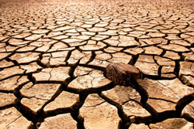**Global temperature rise**

All three major global surface temperature reconstructions show that Earth has warmed since 1880.[5](http://climate.nasa.gov/evidence/#footnote_5) Most of this warming has occurred since the 1970s, with the 20 warmest years having occurred since 1981 and with all 10 of the warmest years occurring in the past 12 years.[6](http://climate.nasa.gov/evidence/#footnote_6) Even though the 2000s witnessed a solar output decline resulting in an unusually deep solar minimum in 2007-2009, surface temperatures continue to increase.

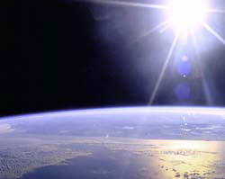

**Warming oceans**

The oceans have absorbed much of this increased heat, with the top 700 meters (about 2,300 feet) of ocean showing warming of 0.302 degrees Fahrenheit since 1969.

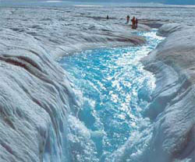Flowing meltwater from the Greenland ice sheet

**Shrinking ice sheets**

The Greenland and Antarctic ice sheets have decreased in mass. Data from NASA's Gravity Recovery and Climate Experiment show Greenland lost 150 to 250 cubic kilometers (36 to 60 cubic miles) of ice per year between 2002 and 2006, while Antarctica lost about 152 cubic kilometers (36 cubic miles) of ice between 2002 and 2005.

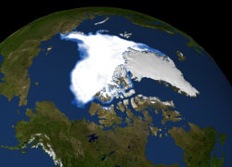Visualization of the 2007 Arctic sea ice minimum

**Declining Arctic sea ice**

Both the extent and thickness of Arctic sea ice has declined rapidly over the last several decades.

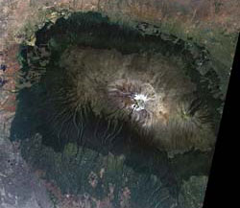

The disappearing snowcap of Mount Kilimanjaro, from space.

**Glacial retreat**

Glaciers are retreating almost everywhere around the world — including in the Alps, Himalayas, Andes, Rockies, Alaska and Africa.

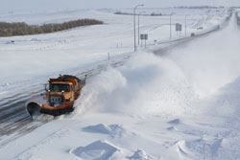

**Extreme events**

The number of record high temperature events in the United States has been increasing, while the number of record low temperature events has been decreasing, since 1950. The U.S. has also witnessed increasing numbers of intense rainfall events.[11](http://climate.nasa.gov/evidence/#footnote_11)

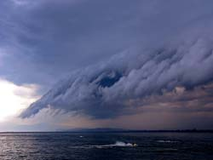

**Ocean acidification**

Since the beginning of the Industrial Revolution, the acidity of surface ocean waters has increased by about 30 percent.[12,](http://climate.nasa.gov/evidence/#footnote_12)[13](http://climate.nasa.gov/evidence/#footnote_13) This increase is the result of humans emitting more carbon dioxide into the atmosphere and hence more being absorbed into the oceans. The amount of carbon dioxide absorbed by the upper layer of the oceans is increasing by about 2 billion tons per year.